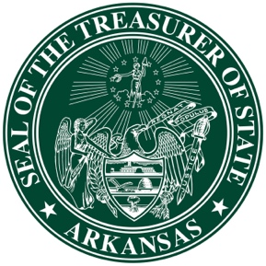

November 27, 2019

For Immediate Release

Media Contact: Stacy Peterson
Phone: 501-682-3838 office; 501-519-3650 cell
Email: stacy.peterson@artreasury.gov

New holiday celebrates the power of college savings for Arkansas students
Savings Sunday encourages families to plan ahead

Little Rock, AR – Sunday, December 1, 2019 has been designated as Savings Sunday by Arkansas Treasurer of State Dennis Milligan. Research suggests that on average, college tuition triples every 17 years. According to the U. S. Census Bureau, college graduates will earn an average of $1 million more over their lifetime than a high school graduate.

“Student loan debt is now the second-highest debt category behind mortgages, so I wanted to set aside a day for families to start a conversation about saving for continuing their child’s education,” Milligan said. “Savings Sunday was established to create a day to help families become mindful of their children’s and grandchildren’s future education desires and expenses.”

The Arkansas 529 Education Savings Plan, a 529 program administered by the Treasurer of State’s office and available to investors nationwide, combines state and federal tax advantages with trusted investment management to assist in reaching college savings goals. By saving with the Arkansas 529 plan, unique tax advantages are available to the investor.

“Many families kick off the season with shopping on Friday and Saturday and plan on giving on Tuesday. So what better day to talk about saving for education than Sunday,” Milligan said.

The Arkansas 529 plan encourages parents and grandparents to establish and contribute to their child’s education. Parents can open plans for as little as $25 and can contribute as little as $10 a month, and receive a state tax deduction of up to $10,000.

“The gift of an education can last a lifetime,” Milligan said. “The Arkansas 529 plan creates flexibility for education and allows college to become a reality for students, regardless of their family’s financial background.”

The plan can be used toward any eligible college, university, trade or vocational school worldwide, and even in public or private k-12 institutions.

###

Dennis Milligan was elected Treasurer of State in 2014 and re-elected in 2018. The State Treasury is responsible for overseeing the state’s $4 billion investment portfolio and administering the Arkansas 529 Education Savings Plan. Since taking office in 2015, Milligan has receipted the state more than $300 million in investment returns and has grown the Arkansas 529 plan’s assets by $374 million.

For more information, visit Arkansas529.org, follow us on Facebook, on Twitter or call 501.682.1406. #AR529

