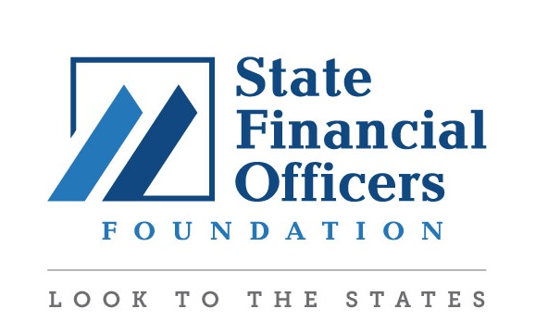
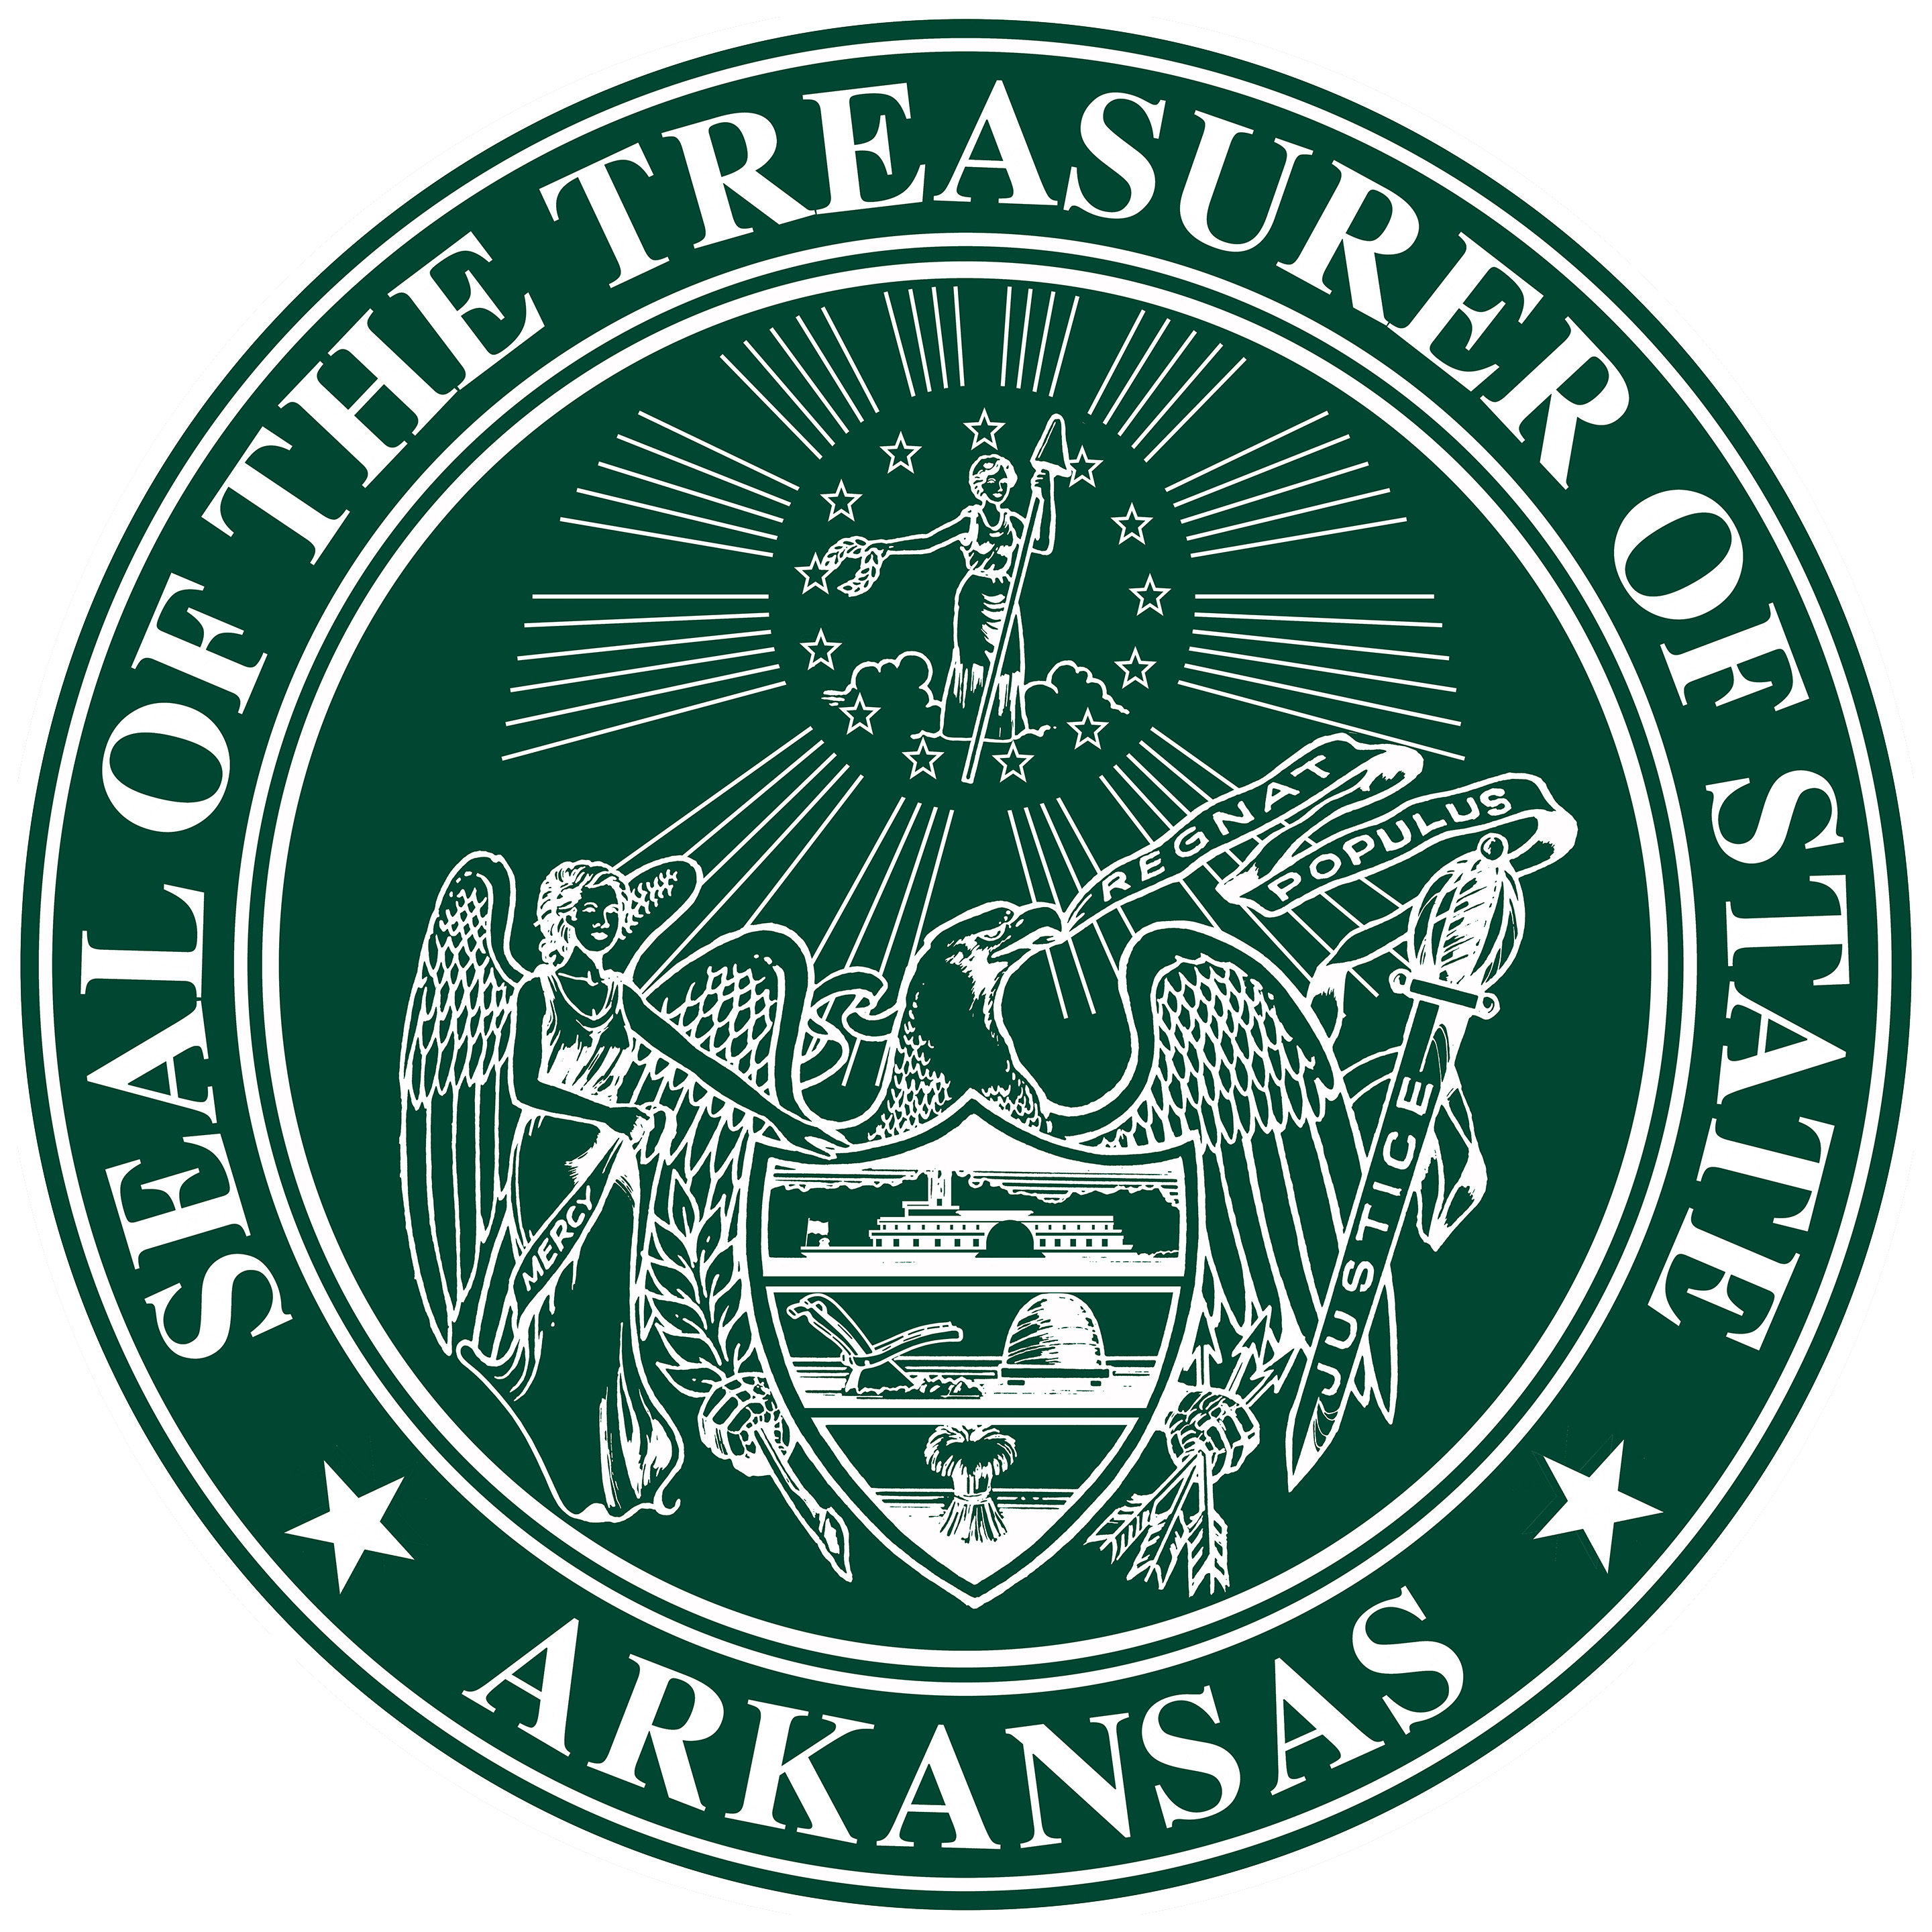

For Immediate Release
PRESS RELEASE
March 20, 2019

Contact: Stacy Peterson
Arkansas Treasurer of State
Communications Director
(501) 682-3838

Treasurer Dennis Milligan to Bring Smart Women Smart Money Conference to Rogers

(Little Rock, Ark.) – Treasurer of State Dennis Milligan, in conjunction with the State Financial Officers Foundation, announced today that he is bringing a national women’s financial education conference to Arkansas.

“I am excited to be able to continue the work my office has done to bring financial literacy awareness to the State,” Milligan said. “In an effort to build upon that success, we've partnered with the State Financial Officers Foundation as they work to bring these important financial literacy conferences all across the country.”

Smart Women Smart Money was founded in 1999 by then Idaho State Treasurer Ron Crane. His vision and focus for this effort has led to over 35,000 women participating in the SWSM conference.

Arkansas is the first state to hold the Smart Women Smart Money conference outside the state of Idaho.

“We are so proud to bring the Smart Women Smart Money conference message that it is never too late, or too early, to learn about finances to the great state of Arkansas,” said Derek Kreifels, President of the State Financial Officers Foundation (SFOF), which is based in Kentucky.

Earlier this year SFOF announced that they would be taking responsibility for the successful Smart Women Smart Money program and would be working with various state treasurers, auditors, and other state financial officers to bring the event to states from coast to coast.

The free conference will be held at the Arkansas Arts Academy on Friday, May 3, 2019 from 8 a.m. to 4:30 p.m. More information can be found at www.smartwomensmartmoney.com.

Smart Women Smart Money conferences provide women of diverse ages and circumstances with the necessary information and tools to take control of their financial lives, Kreifels said.

###

For more information:

Contact: Derek Kreifels, President, State Financial Officers Foundation
(866) 816-0873
derek@statefinancialofficers.com

LeAnn Sullivan, Director of Financial Education, SFOF
(208) 899-1843
leann@smartwomensmartmoney.com

Stacy Peterson, Communications Director, Arkansas Treasurer of State
(501) 682-3838
Stacy.peterson@artreasury.gov

